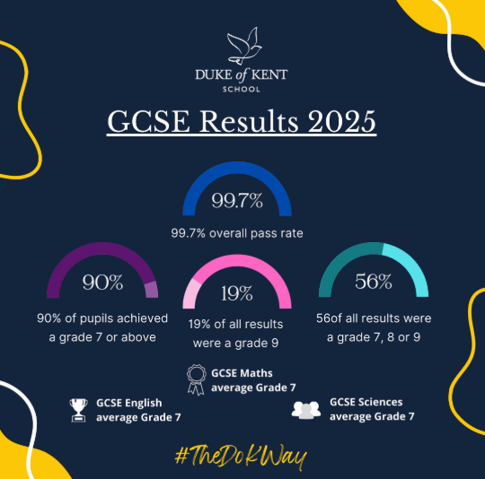
Fantastic GCSE Results for the Class of 2025!
We at Duke of Kent School could not be prouder of our Year 11 cohort! Achieving record breaking GCSE results should come as no surprise given the maturity, character and grit of these fine young people, but to achieve grades like these has blown us away! The whole community feels immense pride, including teachers, support staff, parents and friends, we could not be prouder of their collective achievements. For us, it is also the individual outcomes, at the end of a journey some of our pupils began as three year olds in our Nursery. We have endeavoured to nurture them, and not just their minds but their spirit, their determination, their joy, and their confidence to face life’s challenges and drive on. These results demonstrate that it is not only possible to provide both excellent pastoral care alongside outstanding academic guidance, but in fact the two go hand in hand.
This year saw an overall GCSE pass rate of 99.7%, with a commendable 90% of our pupils gaining at least one grade 7 or above. 100% of pupils passed their Maths, English and Science exams. Indeed, over half of all the grades awarded were a grade 7, 8 or 9. The cohort average across all subjects was a grade 7, with grade 9 making up 19% of the total. This is a truly fantastic achievement for our pupils and each one of our pupils gained entry to their first choice school or college.
It will not be the same without this year group. We will miss their humour, their musical and dramatic talents, their kindness to one another, and the care they showed throughout their time here. We have every confidence in each and every one of them and look forward to their return as lifelong alumni and part of our community. Congratulations to Duke of Kent School, Class of 2025!
Mr Damian Allen
Head of Pupil Progress

