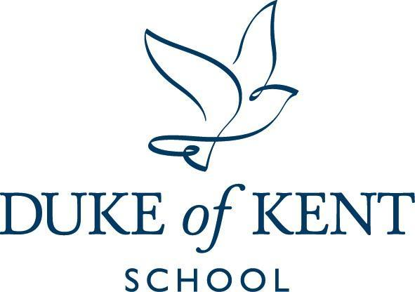

Duke of Kent School Application Pack
MINIBUS DRIVER (Part-time)
Specific hours and runs to be mutually agreed
(early morning runs and afternoon runs available transporting pupils to and from School)
Salary: Competitive based on 34 weeks, term time only
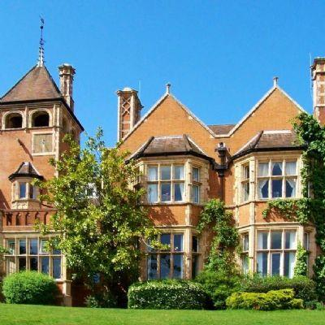

Contents:
- Advertisement
- School Information
- Job Description and Person Specification

Duke of Kent School is committed to safeguarding and promoting the welfare of children and expects all employees and volunteers to share this commitment. Applicants must be willing to undergo child protection screening appropriate to the post, including checks with past employers and the Disclosure and Barring Service. All teaching staff are required to submit a self-declaration form confirming their suitability to work with children across our age range. Appointment will be subject to satisfactory references and pre-employment checks as detailed in our Recruitment Policy.

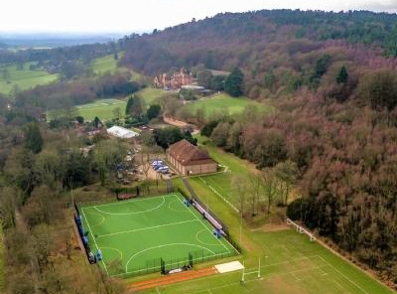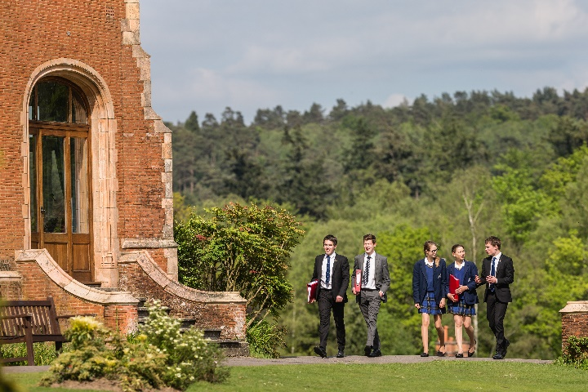

- Advertisement: Minibus Driver
Duke of Kent School is a co-educational day school with 320 pupils from Nursery to Year 11. The School is organised into three sections: Pre-Prep (Nursery to Year 2); Prep (Year 3 to Year 6) and Senior (Year 7 to Year 11).
We seek to appoint a Minibus Driver to join Duke of Kent School on a part-time basis. Precise hours will be mutually agreed and are dependent on the number of morning and afternoon runs undertaken per day.
The successful candidate:
- Will safely transport pupils to/from the School ensuring that they arrive in time for the commencement of the school day/or collected punctually after school
- Will be responsible for promoting and safeguarding the welfare of pupils within the School
- Will report to the Head of Maintenance and Transport

Conditions
- Salary: Hourly rate competitive based on 34 weeks, term time only
- Working in a small, friendly School in a stunning rural location
- Breakfast, lunch & tea, as well as refreshments, provided during term-time, as applicable

How to Apply
Application is by School Application Form only. Forms can be downloaded from the School website under vacancies. www.dukeofkentschool.org.uk/private-prep-surrey-england/job-vacancies
We cannot accept CVs unless accompanied by a completed Application Form. Further information about the school is available on our website. www.dukeofkentschool.org.uk
Applications will be reviewed on receipt.
The contact for this recruitment campaign is Rachel Harris, Head of HR, 01483 277313 or rharris@dokschool.org

2. School Information
Duke of Kent School strives for excellence, expects and celebrates effort, nurtures well-being and presents challenge. Our size allows each pupil to be known and cared for as an individual.
The School has undergone considerable change in the past 13 years, transforming itself from a Prep to a through school, and growing quickly to its current roll of 320 pupils. Key entry points are Nursery, Year 3 and Year 7. Pupils leave at the end of Year 11 to a wide range of local colleges and sixth forms in the independent and maintained sectors.
Our teaching team is made up of experienced, well qualified and highly motivated teachers who have chosen to join our small community where they have a big impact. A dedicated and comprehensive operations staff team supports the teaching team. Across both support and teaching areas, the School currently employs approximately 100 staff (both full-time and part-time). We are also complimented by a team of committed local Governors with broad expertise.
We have a growth mindset, operating on the principle that all learners can, when properly challenged and supported, achieve extraordinary progress. Our focus is on achieving personal best in every aspect of development. We expect, and celebrate effort.
Duke of Kent School works in partnership with parents to support and promote all aspects of pupils’ development. We prepare our pupils to play a positive role in their adult lives, as independent learners and thinkers, and to be responsible members of the local and global community.
We expect all members of the community to exercise tolerance, kindness, respect and empathy. We value diversity and pursue equal opportunities for all.
The greatest gift we give each child is a passion for learning and a real curiosity about the world around them. Here at Duke of Kent School near Guildford in Surrey, we all care deeply about educating the whole child. We are proud of the incredible teaching staff who recognise the individuality and strengths of each of our pupils and challenge them to be the best they can be, whilst allowing them the freedom to be exactly who they want to be.
As well as the best possible academic learning environment, the breadth of the music, drama, creative arts and sports opportunities set us apart. Our after school activities programme is also designed to give the students opportunities to develop new passions and talents.
We are a thriving co-ed independent school and our pupils leave our care as happy, independent, rounded, grounded individuals with many joyful memories, and a desire to go out into the world and make a difference.
The School has an inclusive ethos and we are proud of meeting the needs of pupils across a broad range of academic ability. We seek to enable each pupil to achieve his or her potential, to address challenges and to develop interests and aptitudes.
- Job Description and Person Specification
Role Title | Minibus Driver (Part-Time)  The Line Manager for this post is Paul Aves, Head of Maintenance and Transport
Role Description | To safely transport pupils to/from the School ensuring that they arrive in time for the commencement of the school day/or collected punctually after school.  To be responsible for promoting and safeguarding the welfare of pupils within the School.
Working Hours | Working Hours and salary are dependent on the number of runs undertaken. The paid hours for the runs are as follows:  Monday to Friday morning run: 2 hours  Monday to Friday first afternoon run only: 2 hours  Monday to Friday both afternoon runs: 3.5 hours  Contract term: Permanent (following probationary period of one month)  There is no obligation to carry out 3 runs per day, and flexibility around number of days worked will be considered.
Main Duties and Responsibilities:
- To transport pupils to/from school
- To ensure that the mini-bus has sufficient fuel for journeys
- To inspect the mini-bus prior to departure to ensure road-worthiness and to complete the daily check list
- To ensure that the vehicle is kept clean and tidy
- To ensure that pupils behave in an appropriate and safe manner during transport and any pupil misbehaving should be reported to the Deputy Head
- Any vehicle defects discovered should be reported to the Head of Maintenance and Transport
Professional Practice
- Be aware of and have a proper and professional regard for the School’s policies and procedures, including the Staff Code of Conduct.
- Model at all times the high standards of behaviour, courtesy and respect required from our pupils.
- Make a positive contribution to the life of the community, working to maintain the kind, caring and supportive ethos of the School.
- Promote diversity, equality and inclusion of all members of the community.

Person Specification | Required Skills & Experience:  - Previous driving experience, ideally in passenger transport  - Hold a full UK driving license and with D1 category, and be aged between 21 and 70 years to comply with insurance requirements  - Be prepared to undertake safeguarding training and vetting by the Disclosure and Barring Service (DBS)  - Be prepared to undergo additional training as required including First Aid
Notes | This role is not a teaching but a support role. This job description identifies the key responsibilities attached to the post described. It is subject to amendment from time to time within the terms of your conditions of employment, as the needs of the school may require, after consultation.  Duke of Kent School is committed to safeguarding and promoting the welfare of children and young people and expects all staff and volunteers to share this commitment. Applicants will be required to undergo child protection screening appropriate to the post, including checks with past employers and the Disclosure and Barring Service (DBS)

Safeguarding and Personal & Professional Conduct
Duke of Kent School is committed to safeguarding and promoting the welfare of children and expects all employees and volunteers to share this commitment. Applicants must be willing to undergo child protection screening appropriate to the post, including checks with past employers and the Disclosure and Barring Service. All staff are required to submit a self-declaration form confirming their suitability to work with children across our age range. Appointment will be subject to satisfactory references and pre-employment checks as detailed in our Recruitment Policy.
In addition to a thorough understanding of safeguarding procedures, staff are expected to demonstrate consistently high standards of personal and professional conduct.

This role description identifies the key responsibilities attached to the post described, and is subject to amendment from time to time within the terms of conditions of employment, as the needs of the School may require, after consultation.

This role description stands in addition to the standard expectations of Duke of Kent School staff and to any contractual arrangements.

